**SDS-PAGE gel electrophoresis**

1. **Sodium Dodecyl Sulfate-Polyacrylamide Gel (SDS-PAGE)**
2. **Goal:** to separate and identify proteins according to their molecular weight.
3. **Principle:**

the rate of migration of SDStreated proteins is effectively determined by their unfolded length, which is related to their molecular weight

1. **Polyacrylamide Gel Electrophoresis**
2. **Catalysis: catalyze polymerization**
3. **ammonium persilfate (APS)**

spontaneously decomposes to form free radicals

1. **tetramethylene ethylene diamin (TEMED)**

a free radical stabilizer, is generally included to promote polymerization

1. **Gel:**
2. **Acrylamide:**

co-polymerization, forms linear polymers.

1. **N,N’-methylene-dis-acrylamide:**

cross-linking, introduces crosslinks between polyacrylamide chains.

* Pore size in gels can be varied by varying the ratio of acrylamide to bis-acrylamide
* A high ratio of bisacrylamide to acrylamide and a high acrylamide concentration cause low electrophoretic mobility

Ps: Protein separations typically use a 29:1 or 37.5:1 acrylamide to bis ratio

1. **Steps:**
2. **Extract Protein**
3. **Solubilize and Denature Protein**

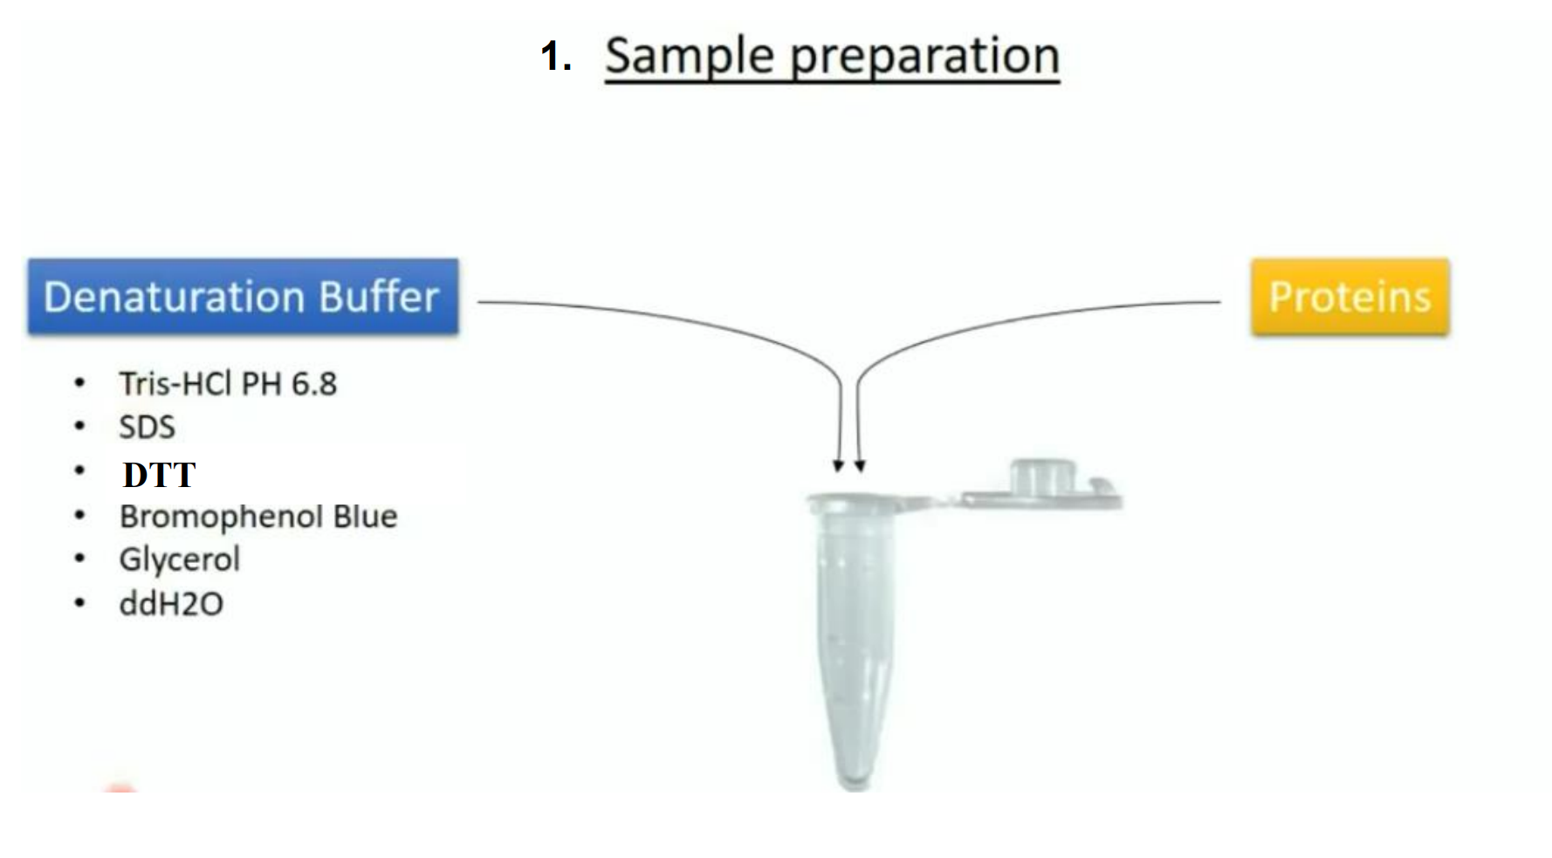

1. **Detergent**

* **SDS:**
* **break hydrogen bonds and unfold protein. Disrupts secondary and** **tertiary protein structure**
* **unravel proteins into linear molecules.**
* **The intrinsic charge of a protein is masked.**

During SDS-PAGE, all proteins migrate towards the anode

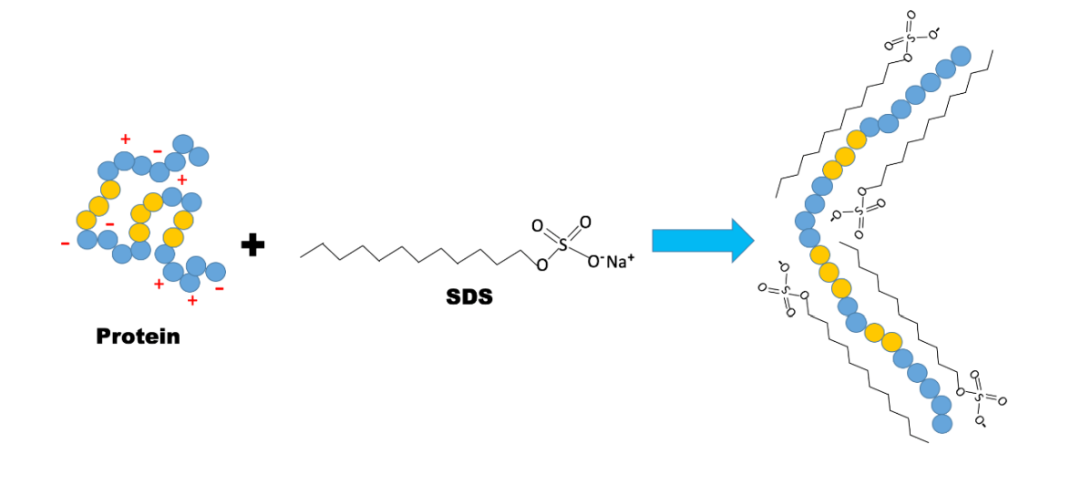

* **DTT:** reducing agents that breaks any covalent bonds between cysteine residues.

1. **Separate Proteins on a gel(discontinuous gel)**
2. **Gel**

* **Stacking** low concentration (5% acrylamide) and low pH
* **concentrate proteins** in narrow band before traveling through separation gel for greater resolution of bands by sandwiching them between a gradient of glycine molecules above and chloride ions below

**Once a protein reaches the separating gel, the proteins pack together in tight bands.**

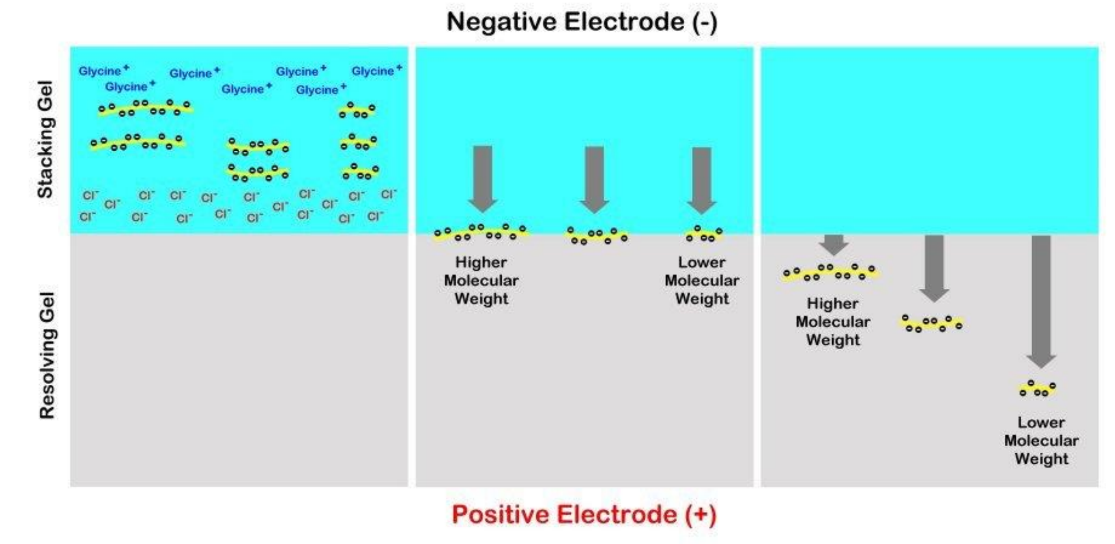

* the bands are much **clearer and better separated for visualization and analysis.**
* most of the proteins will enter the denser resolving gel simultaneously
* **Separating gel** – higher concentration of gel (15% acrylamide) and high pH

begin to migrate downwards at different rates based on their size.

1. **Running buffer (**Tris-Cl, glycine, and SDS, pH 8.3)

Glycine is an amino acid whose charge state plays a big role in the stacking gel

1. **Stain proteins (visualization)**

**Coomassie Blue staining:** It is highly sensitive and is suitable for long-term storage of the gels

1. **Analyze and interpret results**
2. **Procedure**

**A. Casting SDS-PAGE gels**

1. Place the green casting frame on the bench with the green “feet”

resting firmly against the bench and the clamps open (perpendicular to

the frame) and facing you.

3. Place the two gel plates in the frame. Insert the taller spacer plate with

the “UP” arrows up and the spacers facing toward you into the casting

frame

4. Secure the plates in the casting frame by pushing the two gates of the

frame out to the sides.

5. Clamp the casting frame with glass plates into the casting stand, with

the gates of the casting frame facing you.

6. Check the airtightness by pipetting a small amount of deionized water into the gap between the plates.

**B. Prepare resolving/Stacking gel**

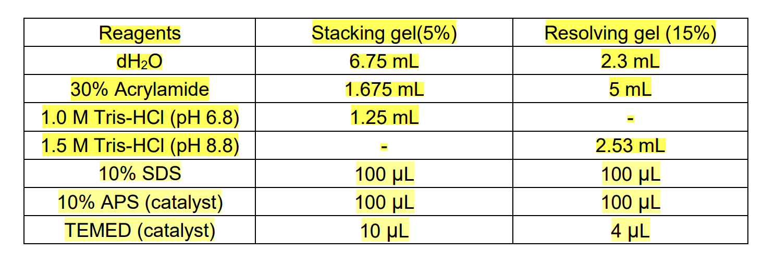

1. **Prepare the resolving gel**
2. Using a transfer pipet, add deionized water so that it gently flows across the surface of the polyacrylamide mixture.
3. Allow the gel to polymerize, which takes ~15-20 minutes until a sharp new interface then forms between the two layers,
4. **Prepare the stacking gel**
5. lower the comb into position carefully
6. Allow the gel to polymerize 30-45 min.

**C. Running SDS-PAGE gels**

Set up the electrophoresis apparatus

1. remove the comb from the gel
2. Remove the casting frame from the gel cassette sandwich and place the sandwich against the gasket on one side of the electrode assembly, with the short plate facing inward.
3. Place a second gel cassette or a buffer dam against the gasket in the other side of the electrode assembly.
4. Clamp the green clamps on the sides of the electrode assembly (below).
5. Lower the chamber into the electrophoresis tank.
6. Fill the space between the two gels with Tris-glycine running buffer.

This forms the upper chamber for electrophoresis.

6. Add Tris-glycine running buffer to the outer (lower) chamber until the

level is high enough to cover the platinum wire in the electrode

assemble

**D. Load and run samples on the SDS-PAGE gel**

1.Mix 200ul of the samples with 50ul of loading buffer

2. Load up to 5, 10, 15 and 20 μL of sample into each well.

3. Load 5 μL of a molecular weight standard into one lane of the gel.

3. Connect the tank to the power supply.

4. Turn on the power supply. Run the gel at a constant voltage of 80V. Run the gel for 30-40min.

5, Change the voltage into 200V. Run the gel for 20-30min until the blue dye front reaches the bottom of the gel.

**E. Staining SDS-PAGE gels**

1. Turn off the power supply.

2. Remove the gel apparatus from the tank.

3.Open the clamping frame and remove the gel cassette sandwich with a plastic slide

3. Clean the gel before staining.

A. Place the gel in a small plastic tray and add 50ml ddH2O to cover the gel

B. Microwaveon high power for 40 seconds until ddH2O boiled

C. Pour off the ddH2O.

4.Staining

A. Incubate the gel in the Coomassie stain (30 mL).

B. Microwave on high power for 40 seconds to 1 minute until boiling and keep boiling for 30-60 seconds.

C. Incubate for 5 to 10 minutes on a rocking table.

D. Recycle the Coomassie Stain.

6. Add fresh H2O (tap water is fine) to cover the gel, incubate for overnight on a rocking table.

7. When individual bands are detectable, record your data using the Gel imaging system.

8. After recording the data, dispose of the gel in the Biohazard waste container.